1. Develop a system using UML for passport management system.

USE CASE DIAGRAM:

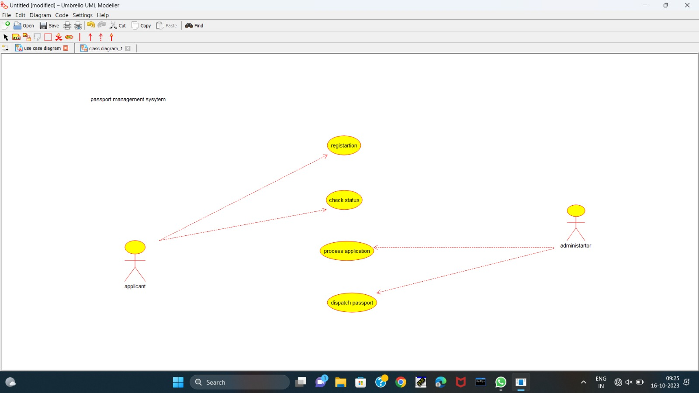

CLASS DIAGRAM:

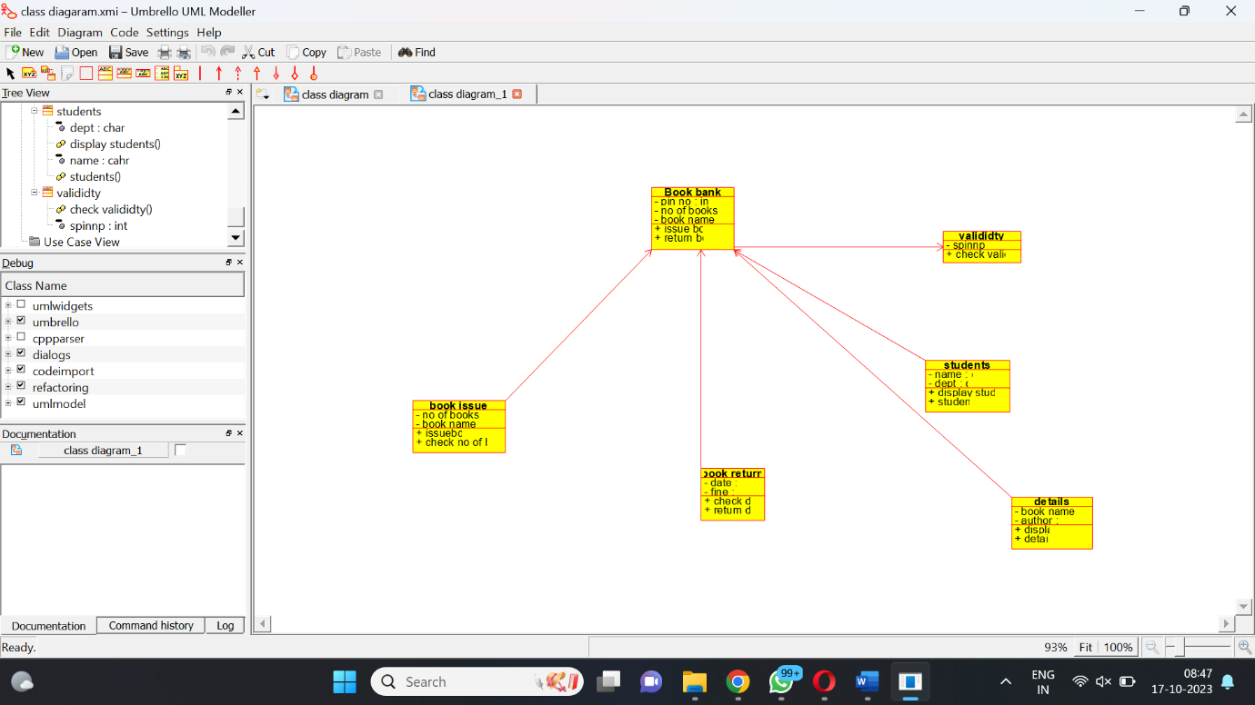

ACTIVITY DIAGRAM:

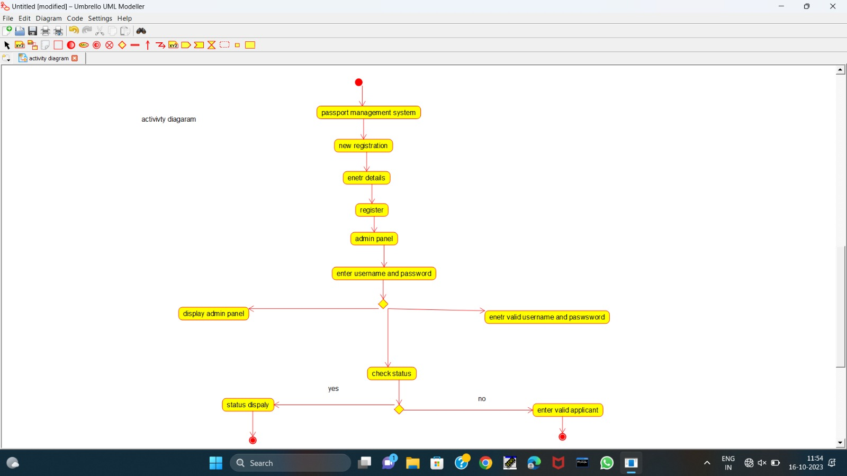

SEQUENCE DIAGRAM:

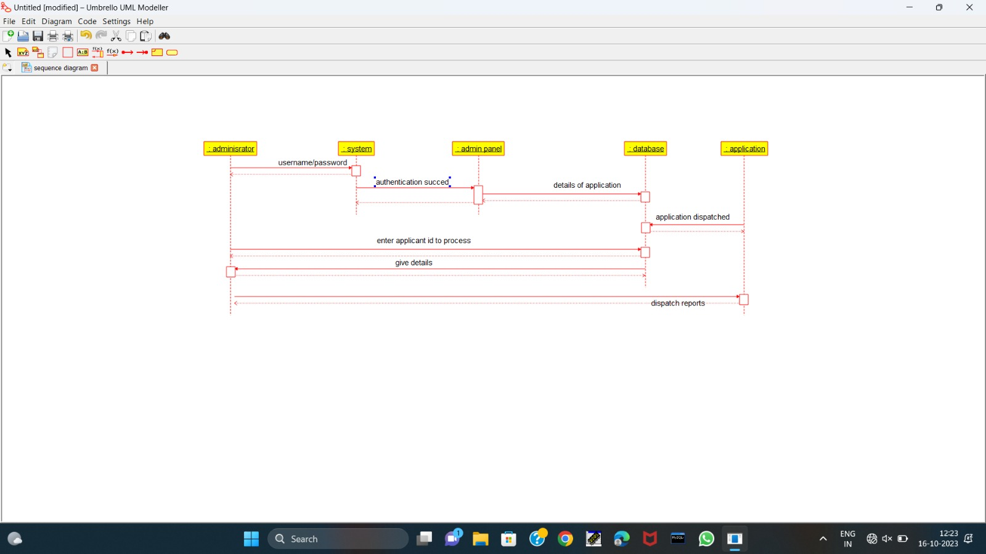

DEPLOYMENT DIAGRAM:

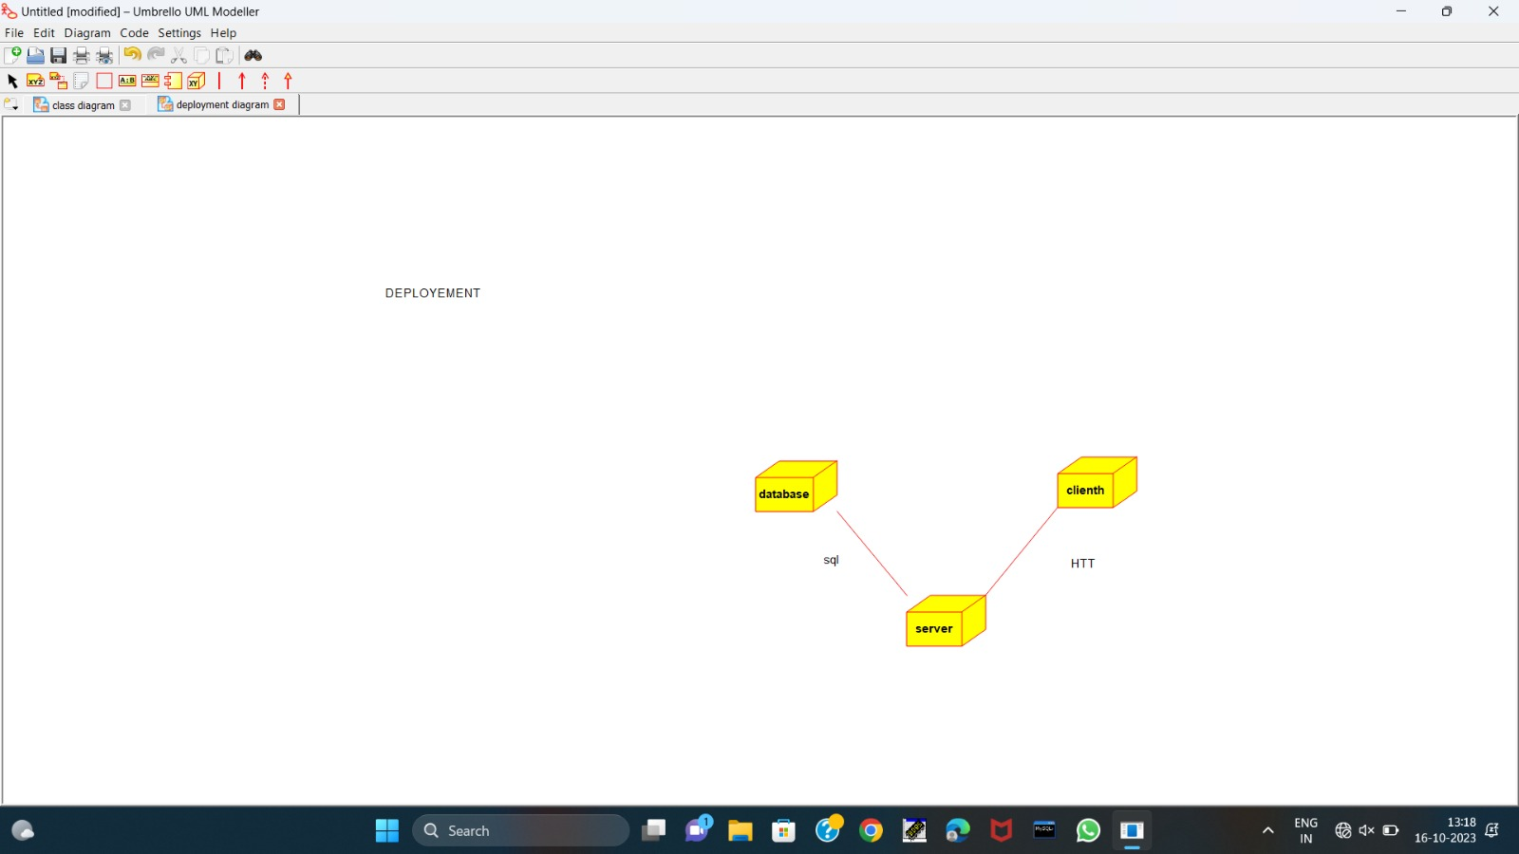

COMPONENT DIAGRAM

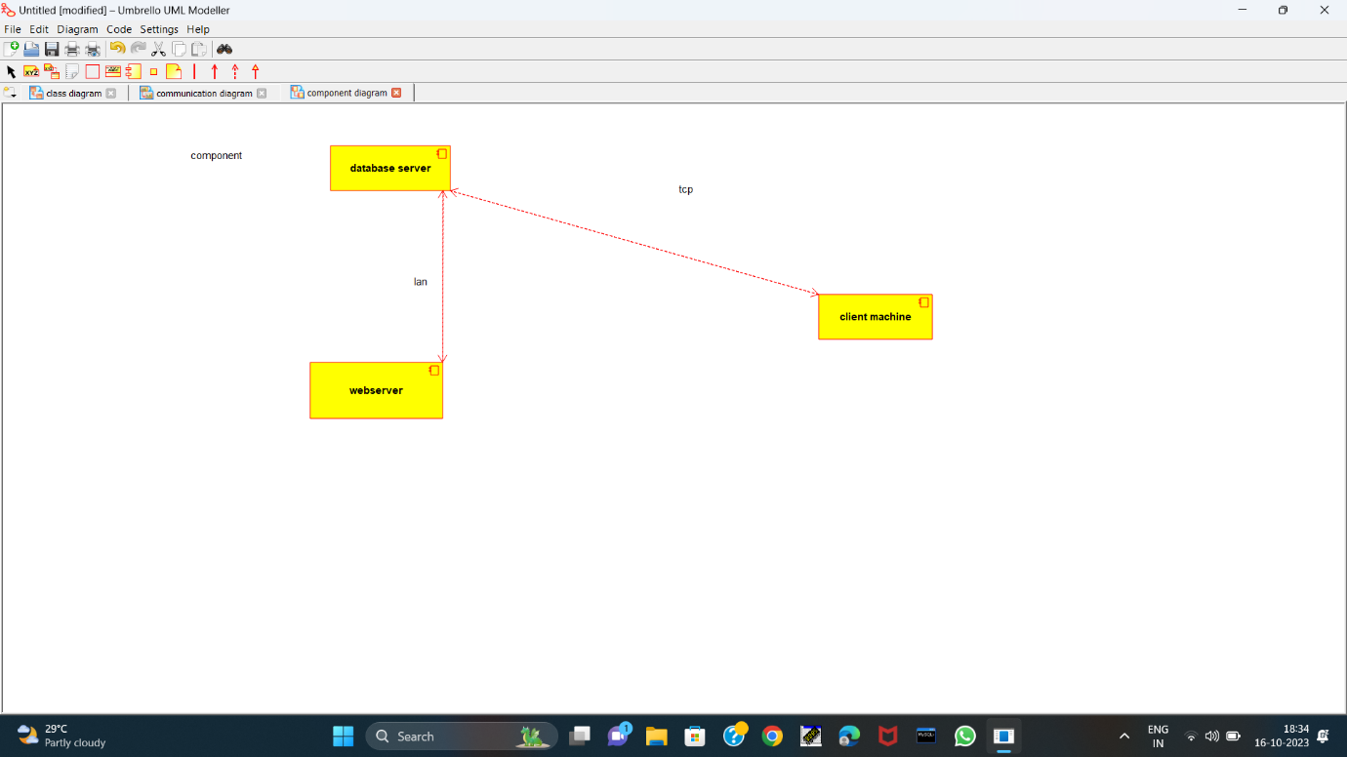

STATE DIAGRAM

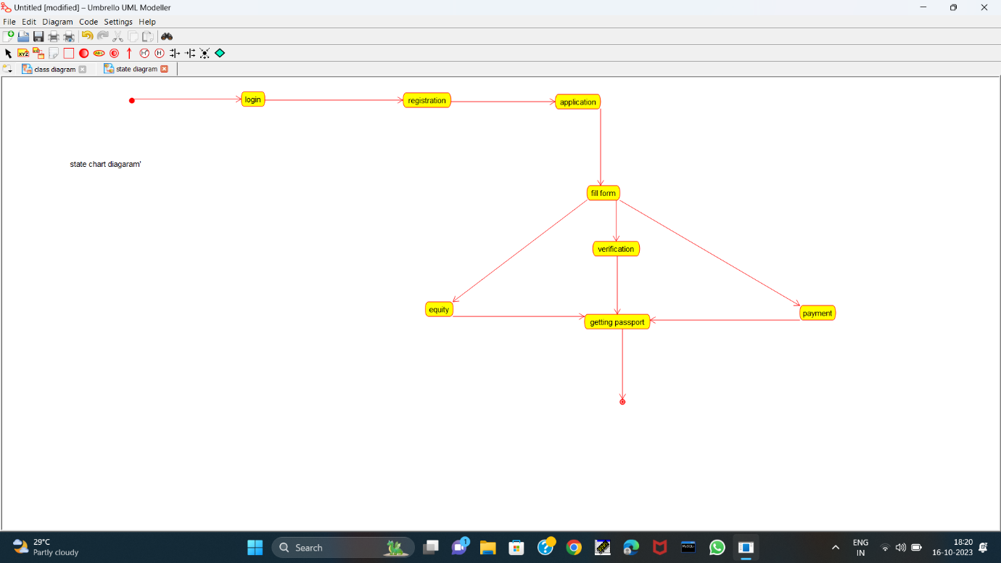

COLLABORATION DIAGRAM:

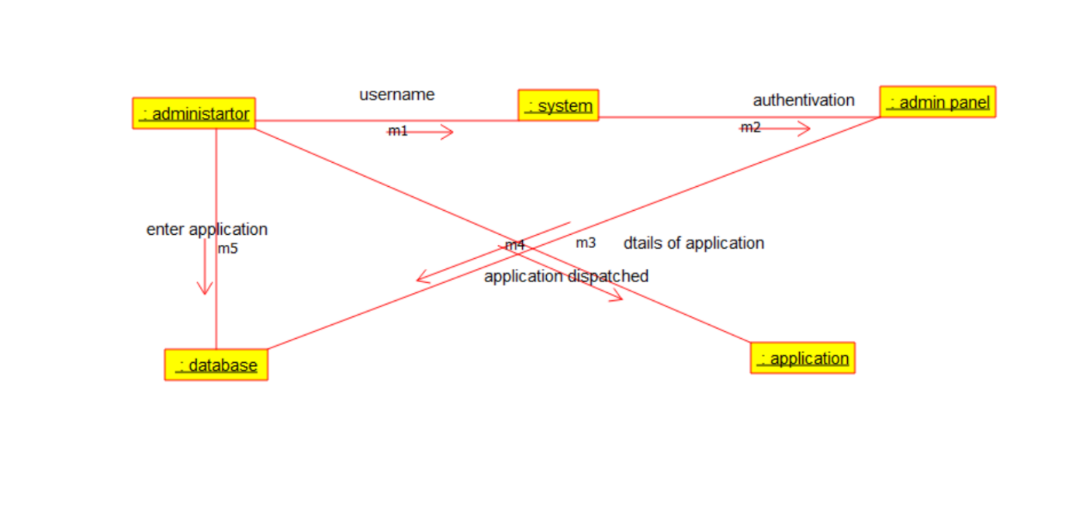

192211012

GB Reenasri